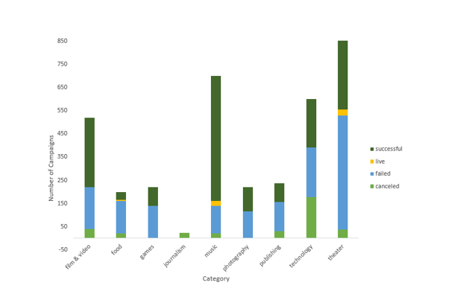

Figure 1: Relationship between number of campaign and category

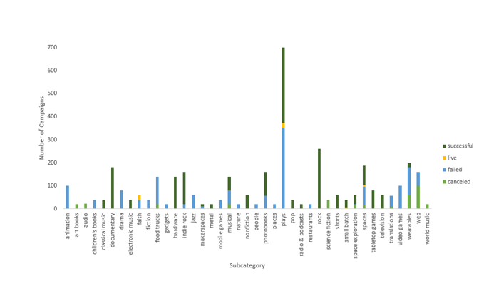

Figure 2: Relationship between number of campaign and sub-category

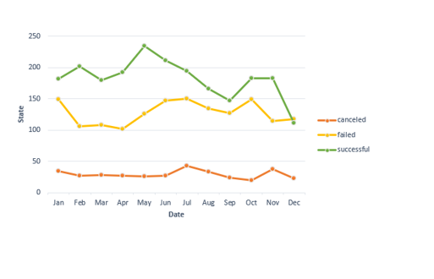

Figure 3: Relationship between campaign state and starting date of campaigns

1. **Given the provided data, what are three conclusions we can draw about Kickstarter campaigns?**

Figure 1 displays, theater and music has best successful rate respectively and the sum of these two category, approximately makes the half of our data population. Moving to Figure 2, subcategory plays has the largest population among the other subcategories. Which in plays subcategories, music has the largest successful population. Looking closely, "metal" is the least successful while “Rock" is the most successful subcategory in music family. World music with the population of 20 is the least favorite subcategory in this family which results to cancelation of this group of music campaign. According to figure 3, the month of "May" is the hot season for the majority of successful projects with a population of over 230 projects/month, while most of the failed projects are in the months of Jan, Jun and JULY. In general, we can see that, the value of each projects in dollar does not insure their success.

1. **What are some limitations of this dataset?**

In this database the exact size of Kickstarter population is unknown and without knowing the exact population size, there are not any metrics that describe the success of each industry/category/sub-category as a whole during the covered time period.

1. **What are some other possible tables and/or graphs that we could create?**
2. Graphs for all the metrics covered with and without “plays” (the most popular category)
3. Tables showing the most successful categories/subcategories versus the most unsuccessful categories/subcategories and detailed data into each category/subcategory’s level of success. Some possible metrics include (1) success rate per category/subcategory, (2) median, max, and min funding goal/target per category/subcategory, (3) median, max, and min of average donation per category/subcategory, (4) median, max, and min of percent funded per category/subcategory, (5) median, max, and min length of Kickstarter campaign timelines per category/subcategory etc.
4. 3. Displays and tables that exclude significant funding goal outliers.